U6+7 Exam
40˚
سبحان الله و بحمده سبحان الله العظيم
My Name …………………………………………………………………………………………………………………………………………..

Q 1: complete:
1-they're open (in – on – at) the evening .
2-It's open (in-on-at) 4 o'clock .
3-It's ( in – on – at ) Monday.
4- It's (in – on – at ) May.

Q 2: what's the matter? (I'm hungry - I'm tired – I'm thirsty )
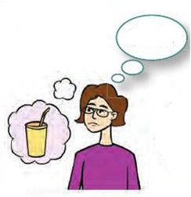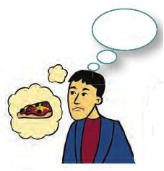
.................................... .......................................

Q 3: Do as shown between brackets :
1-Go ………………..………stand……………………… (add-ing)
2-shop………………………sit………………………….. (add-ing)

3- one mushroom ……………………………………(change into plural)
One onion……………………………………………..(change into plural)

4- one tomato ………………………………………(change into singular)
One potato……………………………………………(change into singular)

5-letsgowiththem (punctuate the sentence)
………………………………………………………………………………………..
6-letswatchtv (punctuate the sentence)
………………………………………………………………………………………..

